1. -Open the Super Store dashboard.twbx

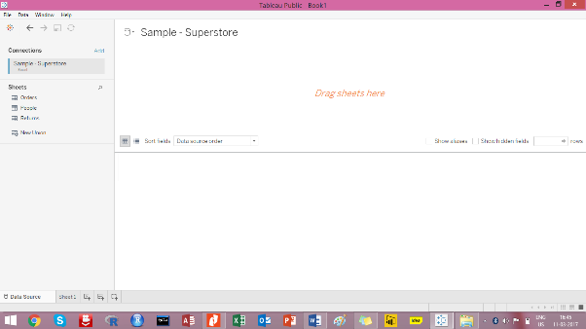

1. Create a bar graph to show the Total Sales across customer segments for various regions

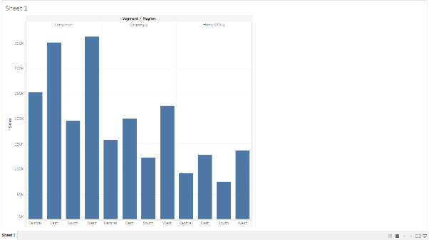

1. Segregate each region with different colors

